Perspectives for graduates
Graduate students from SRE can continue their carer both in industry and research:
- In industry: in reservoir engineering, reservoir geology, and petroleum geophysics;
- In research: in subterranean fluid mechanics and porous media; in applied geophysics
Our graduates are recognized and recruited worldwide by major industrial and service companies and research centres, such as Total, CGG, Schlumberger, Beicip-Franlab, GDF Suez, Paradigm, Shell, Chevron, Exxon-Mobile, Statoil, Soultz Geothermy, Geoproduction Consultants, BRGM, Areva and others.

Graduate students can also work in non-petroleum areas related to the problems of renewable geoenergies, unconventional energy resources, aquifer management, geothermal energy, CO2 storage, radioactive waste storage, mining engineering and various aspects of environment.

Host research laboratories
The host research laboratories in Nancy and Strasbourg in which students perform scientific projects and research internships belong to the Research Federation in Mechanics and Energy and to the Research Federation in Geosciences and Environment:
LEMTA: http://lemta.ensem.inpl-nancy.fr,
CRPG: http://www.crpg.cnrs-nancy.fr,
Géoressources: http://www.g2r.uhp-nancy.fr
The host research laboratories in Strasbourg in which students perform scientific projects and internships belong to
Institut de Physique du Globe de Strasbourg (IPGS):
http://eost.unistra.fr/recherche/ipgs/

Other French laboratories are also accessible:
Institut Jean Rond d’Alembert - University Paris-6; Laboratoire Transferts et Ecoulements Fluides Energétiques - ENSAM Bordeaux; Institut de Physique du Globe de Paris; Ecole Normale Supérieure – Paris, Université de Provence ; School of Mines – Paris Tech.

All courses are in English

Master SRE is the unique French master in Reservoir Engineering and Petroleum Geophysics which is given in English.

Admission

All international applicants must have at least a bachelor degree in one of the following disciplines: fluid mechanics, physics of fluid, applied mathematics, computer science or numerical modelling, geophysics, reservoir engineering, petroleum geosciences, hydrology. Professional candidates seeking a career evolution also are welcome. Applicants must validate their diploma to European level. A good level in English is required and must also be validated.
All candidates are selected on the ground of their application and may be invited to an interview (a video-conference is possible).

Tuition fees

The basic tuition fee for the two-years master-degree program is 12k€. Along with this, students should possess a personal budget sufficient to cover living expenses including accommodation, food, transport and health care. The student card (delivered after enrolment) provides discounts for transport, access to university restaurants and the French national health safety system.

The best candidates have an opportunity to obtain financial support via the Master Jury, of our industrial partners, or the French Government, as well as to be exempt from paying the part of the tuition fees.

Application form & deadline

The application form can be download from:
http://ensg.univ-lorraine.fr/pages/options/srehgm.htm
The application should be mailed to the master secretary:
Sandie FANTIN
International Master – ENSG – INPL
Rue du Doyen Marcel Roubault, BP 40
F-54501 Vandœuvre-lès-Nancy Cedex – France
sandie.fantin@univ-lorraine.fr
Larisa Allé , Filial Branch in Kazakhstan
UdL, Centre Geo-Energies
ENSEM, 2 av. Foret de Haye, BP 160
F-54501 Vandœuvre-lès-Nancy Cedex – France
larisa.alle@univ-lorraine.fr

The completed application must be mailed
before June 1st

French Ministry of Higher Education and Research

SRE
SUBTERRANEAN RESERVOIRS of ENERGY
Hydrodynamics, Geophysics, Modelling

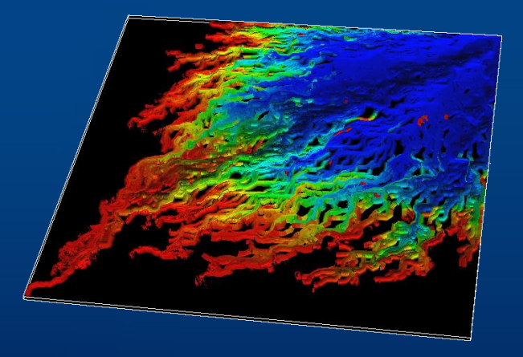
International English-Speaking Master
Marcellin GUILLEMIN
Director of the Centre Geo-Energies
French Embassy in Kazakhstan
centre.geoenergies@gmail.com
+7 727 377 35 22
Irina PanfilovA
As.Prof. HDR - ENSG
University of Lorraine
irina.panfilova@univ-lorraine.fr
(33) 3 83 59 55 96

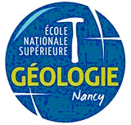
http://www.univ-lorraine.fr/content/master-subterranean-reservoirs-energy-sre
Objectives

The objective of this Master program is to train specialists for combined engineering and scientific careers. The strong scientific specialisation determines the difference of this master from all other master programs in this domain. We form engineers of high scientific level.

SRE trains students in the following domains:
- Conventional energy resources: oil, gas, uranium leaching;
- Non-conventional geoenergies: bitumen, shale gas, gas hydrates, coalbed methane, geothermy; tight gas reservoirs;
- Underground storages of natural gas, CO2, hydrogen, electricity
- Hydro-thermodynamics of exploitation of different types of subterranean energy reservoirs.
- Engineering methods of predicting, controlling, modelling, and optimising recovery scenarios;
- Simulation and 3D-modelling of reservoir geological structures and reservoir dynamic processes.
- Reservoir geology and geophysics.

Training organisation

The training period is 2 years, starting in September:
- 1st year: academic courses at UL common for all students;
- 2nd year, 1st semester: 6 months of courses in UL for specialty Reservoir Engineering, and in US for specialty Petroleum Geophysics
- 2nd year, 2nd semester: industrial or research internship

For each year, students should validate 60 European credits. One semester validates 30 credits. The first three semesters represent academic studies – theoretical and practical courses given by national and international experts.

The training is organized within the scope of a unique speciality.

Filial branch in Kazakhstan
The filial branch of Master SRE was created in 2010 in Almaty within the framework of the French-Kazakh Center Geo-Energies : http://geoenergies.univ-lorraine.fr/. Students from this filial follow the same training program and obtain the double French-Kazakh degree.
Training program – 1st year
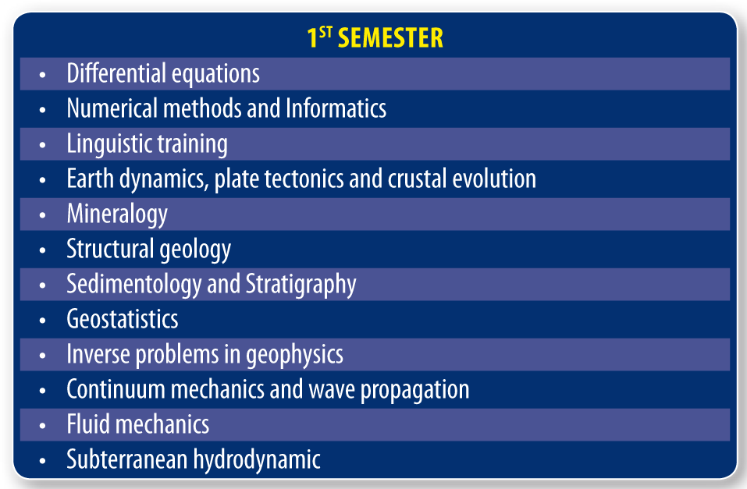

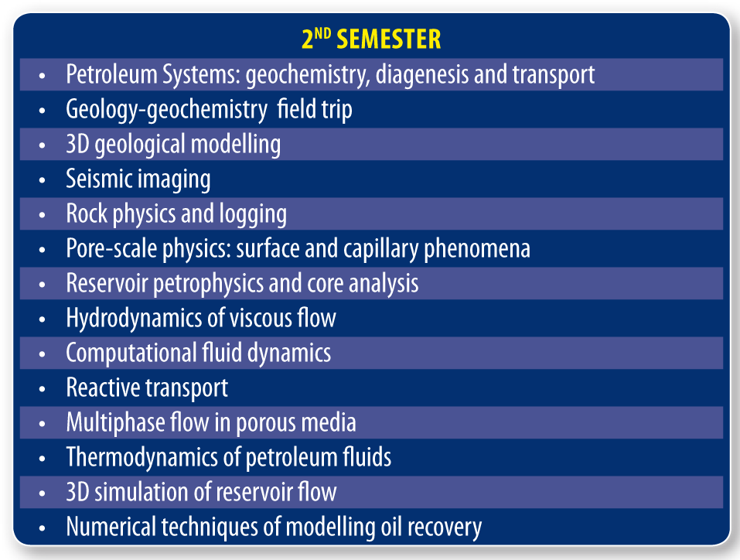

Each module consists of 25h. The evaluation is done by oral or written exam or by a mini-project.

The last part of the second semester is devoted to a M1 research project, which consists of creating a 2D numerical model (programming) of a hypothetic scenario of reservoir exploitation. The project (60 hours) validates 6 credits.

During the summer recess, students can do a first short internship (non-obligatory).

Training program – 2nd year

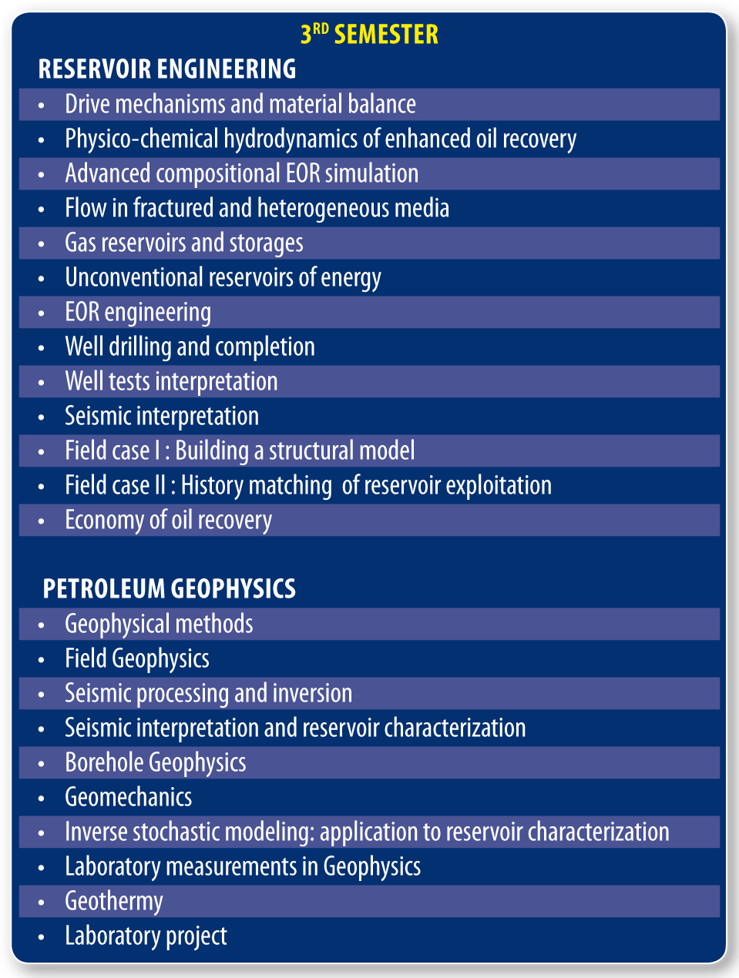

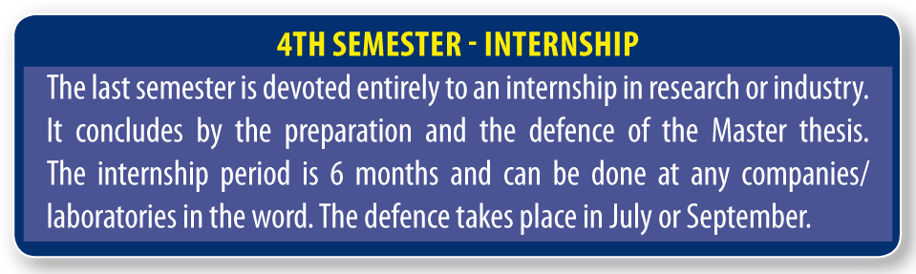

The Field Case represents the simulation of an exploration and recovery project on a real oil and gas field which involves constructing the exploration and appraisal of the reservoir, followed by geological modelling and simulation of oil-gas recovery scenarios. This multidisciplinary work takes 3 full weeks and finishes with competitive presentations of each team’s results.

